**EXPERIMENT 3**

**ILLUSTRATION OF DEMORGAN'S THEOREM**

**Objective:**

To verify DE Morgan’s Theorem & To realize sum of product (SOP) and product of sum (POS) expressions using universal gates

**Required IC’s:**

7408 AND Gate

7432 OR Gate

7400 NAND Gate

7404 INV Gate

7402 NOR Gate

**Theory:**

DeMorgan's theorem allows large bars in Boolean expression to be broken up into the smaller bars over individual variables. DeMorgan's Theorem says that the large bar over several variables can be broken between variables if the sign between the variables is changed. DeMorgan proposed two theorems that are used frequently in Boolean algebra.

**The DeMorgan's first theorem is stated as follows:**

The complement of a product of variables is equal to the sum of the complements of the variables. In another way, the complement of the two or more ANDed variables is equivalent to the OR of the complements of the individual variables.

1st Theorem: NAND Gate Negative OR Gate

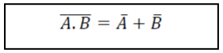

**The DeMorgan's second theorem is stated as follows:**

The complement of a sum of variables is equal to the product of the complements of the variables. In another way, the complement of the two or more ORed variables is equivalent to the AND of the complements of the individual variables.

2nd Theorem: NOR Gate Negative NAND Gate

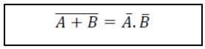

From the above equation, it clear that a NAND gate is equal to a negative-OR and NOR gate is equal to a negative-AND inputs.

**PROCEDURE:**

**Part A- Verifying DeMorgan 1st Theorem**

1. Construct the circuit diagram on breadboard based on the Figure 2 below.

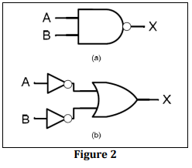

1. Verify the operation for circuit in Figure 2(a) by completing the Table 1(a) below

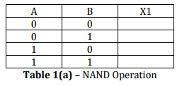

1. Verify the operation for circuit in Figure 2(b) by completing the Table 1(b) below.

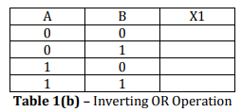

1. Using the above results construct the truth table for each circuit. Show that these circuits verify DeMorgan’s 1st Theorem.

**Part B- Verifying DeMorgan 2nd Theorem**

1. Construct the circuit diagram on spreadsheet based on the Figure 3 below.

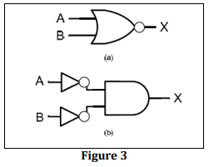

1. Verify the operation for circuit in Figure 3(a) by completing the Table 2(a) below

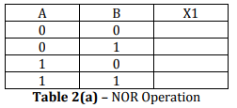

1. Verify the operation for circuit in Figure 3(b) by completing the Table 2(b) below

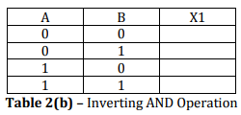

1. Using the above results construct the truth table for each circuit. Show that these circuits verify DeMorgan’s 2nd Theorem.

**CONCLUSION**